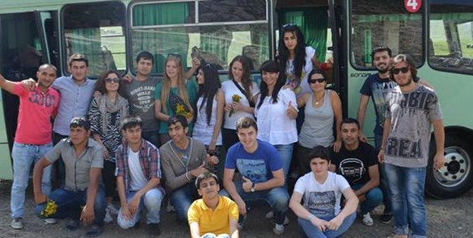
“Bridge to the Future” is an independent national youth NGO established in April 2000 in Ganja which is the second city of Azerbaijan. The strategic mission of the organization is to be a “BRIDGE” for young people to the society, where humanism, solidarity, and co-operation are leading. As NGO we mainly promote work camps, summer camps, youth exchanges, seminars and trainings, conferences, study visits and excursions.

Below you can see information regarding the voluntary work camp program in Azerbaijan for 2017. This year we decided to organize only one short term summer work camp.

CODE | NAME | LOCATION | WORK | FROM | TO | VOL | NOTE
BFWC01 | Let's English lead in children's world | Ganja | Kids | 10.08 | 20.08 | 8 | +18

BFWC01
Dates: 10.08.2017– 20.08.2017 Let's English lead in children's world
Type: Kids Age: 18+ 8 VOLS

Work: During the project volunteers will be working at the kindergarten called Ganja International Kids Club where kids are taught in English mostly. Volunteers with the assistance of teachers will organize outdoor activities such as sport actions: games, energizers, small competitions, teach English to the children and do arts with paintings, music and etc.
Accommodation: Volunteers will stay at Youth Center of Ganja. It’s not necessary to bring sleeping bags or mats.
Language: English
Location: Ganja is the second largest city in the country, a monument of the ancient culture, the industrial center of western Azerbaijan. City with a history that goes back to 494 BC (in 2013 Ganja celebrates 2507 anniversary) is of great interest for tourists. This area has a rich natural, cultural and historical heritage.
There are a lot of forests, vineyards, lakes, rivers and mountains. The area is famous for many mineral springs and unique medicinal oil – Naphthalan. More about Ganja: http://www.ganja2016.eu/en/about-ganja
Registration fee: No fee

