< NICE NEW PROJECTS IN JAPAN>
Code | Name | Location | Country | Start | End | Type | Vols. | Min age | Max age
NICE-17-139 | Hitachiomiya | Ibaraki | Japan | 07/29 | 08/07 | CULT, AGRI, ENVI | 6 | 18 | 99
Summary | The empowerment of local traditional festival in the region facing aging and depopulation.
Background | This project is newly organized with Nagakura Tanabata Festival (NTF) executive committee in Hitachiomiya city. Tanabata festivals (Star Fest) are traditionally held throughout Japan in July, a date based on the old Chinese calendar. However, these festivals have been abolished in many places due to shortage of successors. Nagakura area is also facing aging and depopulation problems nowadays, and NTF committee is trying to preserve traditional NFT, which has been started since 1953 to activate the area after World War II.
Work | There are 2 mainly works. Schedule of work might be changed due to weather condition.  1) Helping a small but valuable traditional Tanabata Festival, such as cutting bamboos and making traditional bamboo decorations, setting up and cleaning up festival facilities.  2) Helping the local organic farmers to work on their farm such as cutting glasses or harvesting.
Accommodation | Home stay. Volunteers will stay in one house and share rooms. Meals will be cooked by volunteers by turns. Sleeping bag is needed.
Study theme | Volunteers will get knowledge about Japanese traditional festival and organic farming.
Other activities | Cultural exchange party with local people and onsen (hot spring).
Location | Nagakura area of Hitachiomiya city. Hitachiomiya is northwest of Ibaraki prefecture.
Terminal | The nearest international airport is in Tokyo(Narita/Haneda). From Tokyo to the meeting point, it takes 3 hours by bus. You need to arrive at the airport in Tokyo(Narita/Haneda) by 9:00 AM on July. 29th and can leave there after 17:00 PM on Aug 7th.
Requirement | Interested in Japanese culture, adaptability to simple living condition, and positive attitude to work outside in hot weather.
Participation fee | No fee
Language | English (Japanese is also welcomed!)
Other | None
 | 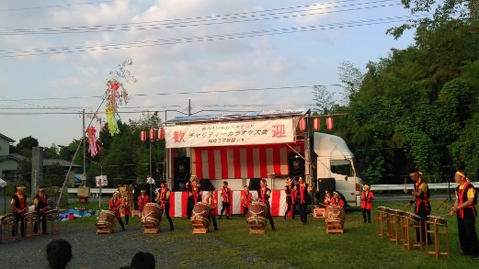 | 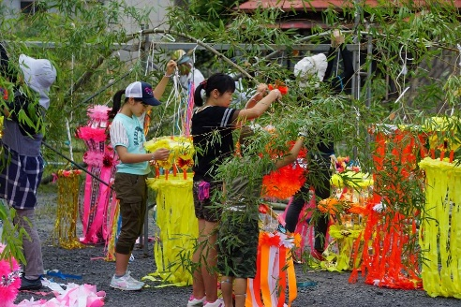
Code | Name | Location | Country | Start | End | Type | Vols. | Min age | Max age
NICE-17-135 | Misato | Shimane | Japan | 10/11 | 10/24 | FEST, ENVI | 8 | 18 | 99
Summary | Let's prepare and join a local festival related to Shintonism to activate people in remoted area and to hand over traditions to the next generation!
Background | This workcamp has been organized with the local group, “an executive committee of Light and Tradition festival” since 2011. Recently, aging and depopulation of the area is getting very serious as well as many other rural villages in Japan. They expect the workcamp to activate local traditional festivals related to Shintonism, which is Japanese traditional religion. This event is combined with 2 events called “Bamboo Lantern Festival” and "Gaku-uchi" which locals play Japanese drums and flute with walking around the village to wish for the productiveness of grain . Local people want us to know their traditional cultures to be succeeded to the next generation.
Work | Volunteers will mainly prepare and join the local festival. Cut bamboos to make lanterns and some small tools to be used in the festival. Volunteers will also need to practice traditional(but easy) music in every evening with local people to play and walk around the villate at the festival. Volunteers will also organize a program in the elementary school to promoting both inter-cultural learning and also the festival to the children.
Accommodation | In the local community center. Meals will be cooked by volunteers by turns.
Study theme | You can get the knowledge about Japanese traditional festivals and customs.
Other activities | Japanese Shinto music and dance, home stay, lecture about traditional cultures.
Location | Misato-cho located in the middle of the Shimane prefecture, famous for Iwami silver mine as a world heritage. There is hot spa, beautiful nature.
Terminal | The nearest int'l airport is Kansai(Osaka). From Osaka to the meeting point in Shimane, it will take 6.5 hours by bus. You are recommended to arrive at Kansai on 10th since the bus leaves early morning. Hiroshima airport is also available, it takes about 4 hours to the meeting point.
Requirement | Interested in Japanese old culture, positive attitude to communication with local people
Participation fee | No fee
Language | English (Japanese is also welcomed!)
Other | None
Picture (Area) | Picture (Work) | Picture (Accommodation)
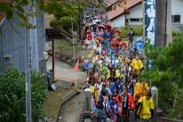 | 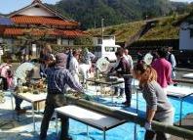 | 