ELIX NEW WORKCAMPS 2017
SUMMER IN THE CITY VII AND VIII
CODE | NAME | LOCATION | TYPE | START | END | AGE | No of Vols | Remarks
ELIX11 | SUMMER IN THE CITY VII | Athens | SOCI/KIDS | 01/07/2017 | 15/07/2017 | 18+ | 10 | ML, CGC
ELIX12 | SUMMER IN THE CITY VIII | Athens | SOCI/KIDS | 15/07/2017 | 29/07/2017 | 18+ | 10 | ML, CGC
PARTNER
ELIX will organize for the fifth consecutive year this type of workcamps. The workcamps aim to support families that encounter difficulties, by providing their children the opportunity to spend a quality summer time at school through creative activities.

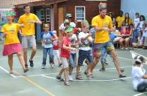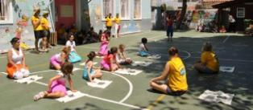

WORK
Volunteers participating in the workcamp will host children (6-12 years old) during their free summer time and organise a fun and diverse daily schedule. The children will be Greek children and children with migrant background and refugee status. The volunteers will organize athletic activities, workshops, artistic events, theatrical plays, environmental and cross cultural education and much more.
Volunteers will work with children from Monday to Friday from 8:00H to 14:00H. The first Sunday of the workcamp will be a short training and introduction necessary for the following weeks. Some afternoons will be used to prepare activities for the kids for the following days. The daily activity program for the children will be fixed by a team of pedagogues and introduced to the group of volunteers on the first Sunday of the workcamps. The pedagogue will be present throughout the programme.

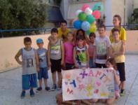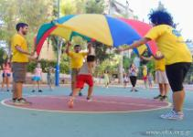

ACCOMMODATION & FOOD
Volunteers will be accommodated in a primary schools the district of Athens Kypseli. The accommodation is basic but adequate; volunteers will sleep on the floor in the classrooms of the school. Sleeping bags and carry mats are necessary. There are toilets, showers (no hot water) and cooking facilities at the school. Everyday two different volunteers from the group, in shifts, will be responsible for maintaining the group accommodation place clean, as well as for the preparation of all the meals for the group of volunteers.

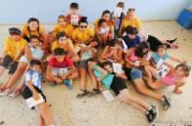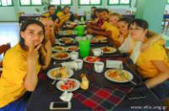

LOCATION & LEISURE TIME
Athens and its suburbs
Athens is a city with glorious history and culture that gave birth to democracy, arts and science and has been worshipped by gods and people, a magical city and enchanting capital of Greece. The most important civilization of ancient world flourished in Athens and relives through some of the world’s most formidable edifications. Athens is situated in the prefecture of Attica and extends to the peninsula that reaches up to Central Greece. It is surrounded by mountains Ymytos, Pendeli and Parnitha, northwards and eastwards, and the Saronic Gulf southwards and westwards. The sun is shining over Athens all year round. During summer, the city is much quieter as the majority of inhabitants leave for their summer vacations.
In their free time, participants will have the opportunity to get in touch with the everyday life of the city; they may attend local events (concerts, festival, performances, etc.). Volunteers will discuss their free time activities with their camp leaders; together they are going to organize excursions and visits around the city.

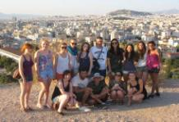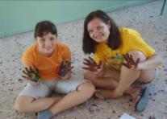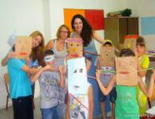

REQUIREMENTS
ELIX is looking for volunteers that enjoy working with children and will support the daily activity program. The volunteers are invited to bring games, songs, ideas, instruments and crafts for the activities with the children!
Due to nature of the workcamp a motivation letter from the volunteer is needed, in order for us to learn more about the volunteer, her/his ideas and motivation for this workcamp.
All the accepted volunteers have to provide ELIX with the original Certificate of Good Conduct.

NEAREST AIRPORT
ATH Athens international airport "El. Venizelos"

CAMP ADDRESS
Athens (to be defined in infosheet)

