Call for participants
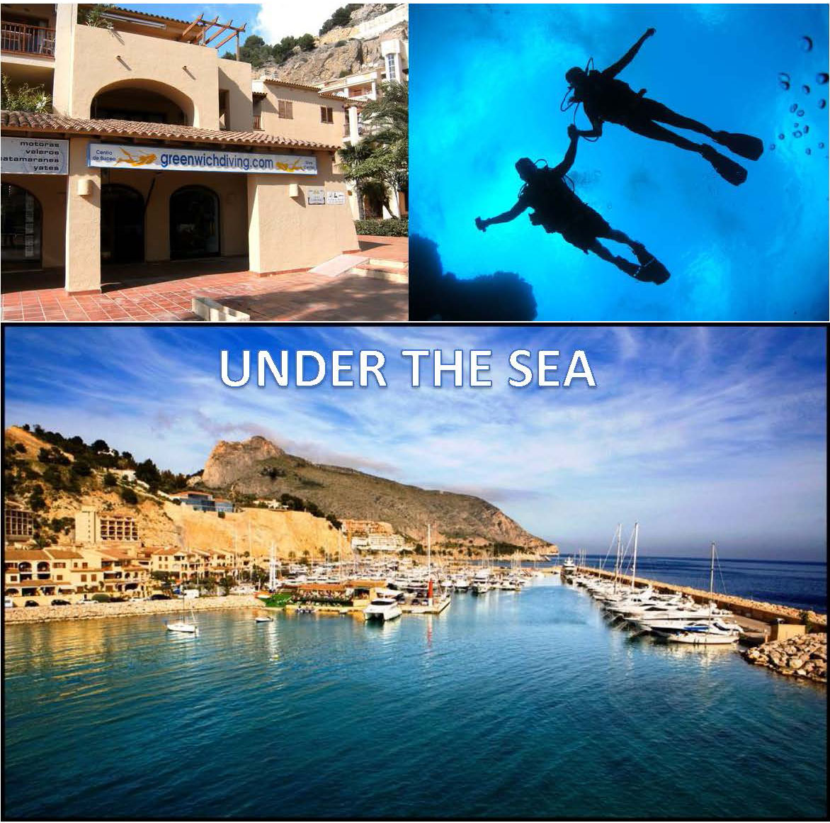
Fotos from greenwichdiving.com
Name of the project: Under the Sea
Code: ESDA-53/17
Language: English, Spanish
Type of work: ENVI/ ARCH
Type of project: short-term (work camp)
Workcamp period: 18th until 30th of April 2017
Age of volunteers: 18+
Number of volunteers: 8 (4 male + 4 female/ 4-5 divers + 3-4 snorkelers)
Project location: Altea, Alicante, Spain
Extra participation fee: 160,00 € for divers and 100 € for snorkelers.
Requirements: For being in the group of divers, you have to already hold the diving license. For being in the group of the snorkelers, you have to have good swimming skills. In general you have to be really motivated and prepared to work hard.
Project address: The camp will take place in Altea (57 km away from Alicante). Participants will be accommodated in the Antiguo Matadero, using mats on beds and sleeping bags/linen (brought by participants). They will cook for themselves in a basic kitchen that will be provided for them.
The accommodation is very basic, but is used only by the participants and located at about 150m from the beach.
Altea is a beautiful, little Spanish town, located in the province of Alicante, in the community of Valencia. It also offers a lot of possibilities to visit other villages around, to go hiking in the mountains, take walks to the nearby lighthouse and just enjoy the sun and the sea. It may be possible to use the 9 places van if one of the volunteers is able to drive.
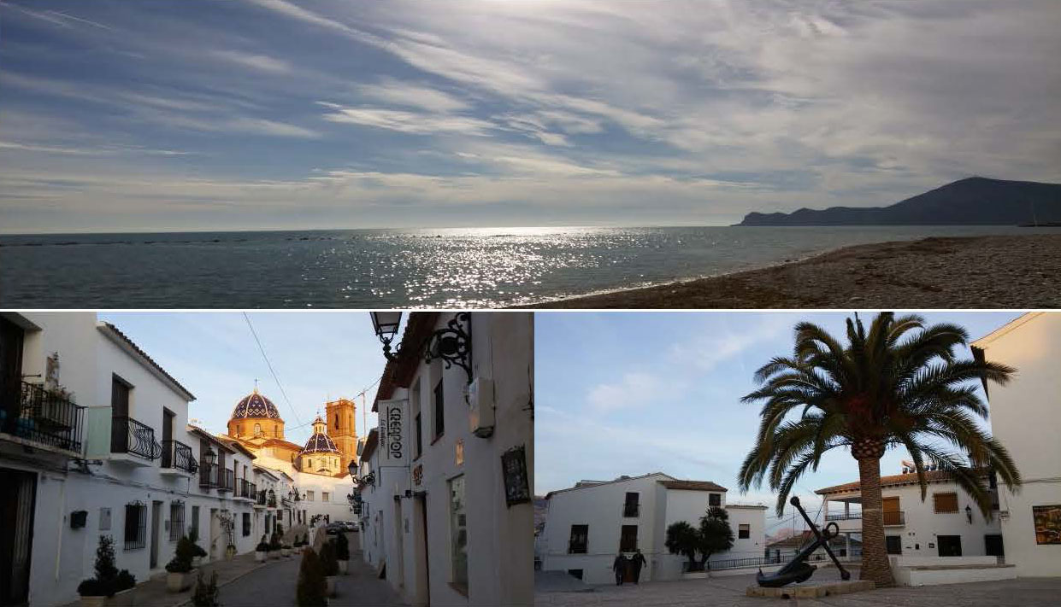
Project and work: All over the World, there is a great impact of human wastes that end up in the sea. Every single fish that is taken out of our oceans carries plastic parts in their organic systems. We all know about the 7th Continent. This impact is even more serious in environmental protected areas and touristic sites like Altea. It is about time to do something!

As an association highly interested in the recovery of environment, De Amicitia decided to organize some volunteering by involving our local partners, the Town Hall of Altea and The Greenwich Diving Center, and we brought up the idea to do meaningful diving and/or snorkeling activities and pursue a higher goal.
Volunteers will gather plastics and old garbage from the sea shore and sea bend. The group will be devided into two: those who have a diving license and those who can only snorkel.
As diving every single day might be too tiresome or depending on weather conditions, we decided to combine this activity with the rehabilitation of the old “Cuartel de Carabinieros” (Carabineers Barracks) which will become an Environmental and Nature Class Room/Museum in future, in the same area. The group may also support the archeologists in their work at an excavation site during the camp. This is as well an interesting, but hard work, which is important for the community, and where the participants can learn a lot.
The workcamp will have 10 working days, 6 for diving and snorkel and 4 for rehabilitation of the old Carabineers Barracks.
Volunteers are asked a fee of 160,00 € for divers and 100 € for snorkelers to cover the very basic costs of full equipment, boat transport to the place to dive and local transport from the work camps lodging to the sea port. De Amicitia is aware of the economical effort volunteers have to make and managed to find a reduction of costs of more than 55-70 % (see https://www.greenwichdiving.com/diving-snorkelling/our-prices/) to be able to offer this project that combines volunteering with the experience of diving/snorkeling. We ourselves keep our normal fee of 30 € for each work camp.

Volunteers will work on:
- Cleaning the seabed and the shore from garbage by diving and snorkling
- Rehabilitation of the “Cuartel de Carabinieros” and other excavation work
- Promoting Volunteering and environmental work

During the workcamp there will be activities for mutual understanding and group building. Volunteers will have free time on the weekends, where activities and excursions to nearby villages can be organized by themselves, with the help of the camp leader and the chance to get to know the place and local environment.
Meeting point: 18th of April 2017 at 19.00 at the Sports centre, Calle Tella 4, Altea
Nearest airport: Alicante (El Altet)

